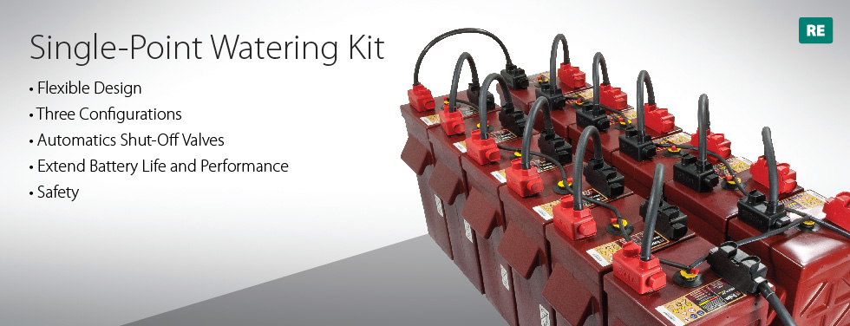

1

Single-Point Watering Kit
Proper maintenance and periodic watering are important factors in maximizing the performance and life of Trojan deep-cycle, flooded batteries. Battery maintenance can be a costly, time-consuming and messy job. With the Single-Point Watering Kit, precise battery watering is made easy, saving valuable time and money.

Flexible Design
The Single-Point Watering Kit is designed to work with flooded deep-cycle batteries and takes the guess work out of properly watering flooded batteries. The flexible tube routing allows the watering system to work with various battery bank sizes and configurations.

Three Configurations
The Single-Point Watering Kit comes in three configurations: 12V, 24V and 48V. The kits are designed for single string installations with Trojan Premium, Industrial and Signature Line flooded batteries*. For systems with multiple strings in parallel, simply order multiple kits at the required system voltage.
There are a total of six different kits that are available for purchase. Three kits are designed for the Trojan Industrial Line (12V, 24V and 48V) and three kits are designed for the Trojan Premium and Signature lines (12V, 24V and 48V)*. The Industrial line watering kit and the Premium and Signature Line watering line kits use different sized vent caps. A vent cap for the Industrial line will not work with the Premium and Signature line batteries and vice versa.

Automatics Shut-Off Valves
Maintaining the proper electrolyte level can extend the performance and life of Trojan flooded batteries. However, determining the correct level can be a challenge. The Single-Point Watering Kit includes automatic shut-off valves, interconnected with tubing, that replace the existing vent caps. A quick coupling allows the system to be connected to a water supply. Once the watering system is installed, water flows into each battery cell until it reaches the correct level. A flow indicator built into the water supply tells the operator when filling has been completed. The entire process generally takes just 30 seconds per battery.

Extend Battery Life and Performance
A properly watered battery lasts longer and performs better. Overfilling a battery can result in loss of acid, while charging with low electrolyte levels can result in permanent damage to the lead plates. Both can result in loss of capacity and life expectancy.

Safety
The Single-Point Watering Kit allows you to fill you deep-cycle batteries without having to remove the vent covers. Avoid battery acid burns, ruined clothing and noxious fumes.
Single-Point Watering Kit User’s Guide
*The Single-Point Watering Kit is compatible with all Trojan Industrial, Premium, and Signature Line flooded batteries except models 24TMX, 27TMX, 27TMH and 30XHS.

